**CAMPUS EVENTS RECORD AND NOTIFICATION SYSTEM**

**(A case study of Federal Polytechnic, Mubi)**

# TITLE PAGE

**BY**

**LAWRENCE TOCHUKWU**

**(ST/CS/HND/23/033)**

**DEPARTMENT OF COMPUTER SCIENCE,**

**SCHOOL OF SCIENCE AND TECHNOLOGY, FEDERAL POLYTECHNIC, MUBI ADAMAWA STATE, NIGERIA**

**IN PARTIAL FULFILLMENT OF THE REQUIREMENTS FOR THE AWARD OF HIGHER NATIONAL/ NATIONAL DIPLOMA (HND/ND) IN COMPUTER SCIENCE**

**JULY, 2025**

# DECLARATION

I hereby declare that the work in this project titled **“Campus Events Record and Notification System (Case study of Federal Polytechnic, Mubi)”** was performed by me under the supervision of Mrs. Betty Temitope Williams. The information derived from literatures has been duly acknowledged in the text and a list of references provided. The work embodied in this project is original and had not been submitted in part or in full for any other diploma or certificate of this or any other institution.

Lawrence Tochukwu ________________ _______________

(ST/CS/HND/23/033) Signature Date

# CERTIFICATION

This project titled **“Campus Events Record and Notification System (Case study of Federal Polytechnic, Mubi)”** meets the regulations governing the award of Higher National Diploma (HND) in Computer Science, Federal Polytechnic Mubi, Adamawa State

Mrs. Betty Temitope Williams __________________

(Project Supervisor) Sign/Date

Mr. Kassim Mustapha __________________

(Head of Department) Sign/Date

Mal. Abdulrahman Saidu __________________

(External Examiner) Sign/Date

# DEDICATION

This project is dedicated to my beloved parents for their advice, encouragement and financial support towards my academic pursuit.

# ACKNOWLEDGEMENTS

I want to acknowledge Almighty God for his infinite mercy and protection throughout my academic activities. And for the understanding in achieving our academic success.

I appreciate my Supervisor Mrs. Betty Temitope Williams and co supervisor Mrs. Lucy Bulus who took time despite her busy schedule to direct and guide me throughout this project work.

I also acknowledge the Head of Department Computer Science Mal. Kassim Mustapha for his moral encouragement throughout my period of study.

I wish to acknowledge all Staff of Computer Science Department for their support and encouragement and the knowledge they have impacted on me throughout my studies.

My appreciation goes to my lovely parents for their love and care and for giving me the opportunity to be trained and achieve my dreams.

Finally, I appreciate the efforts of my Uncles and aunties, for their encouragement and support throughout the course of my study and also my friends and relatives, course mates and all well-wishers. I love you all, may the Almighty God bless you abundantly, Amen.

# TABLE OF CONTENTS

TITLE PAGE i

DECLARATION ii

CERTIFICATION iii

DEDICATION iv

ACKNOWLEDGEMENTS v

TABLE OF CONTENTS vi

LIST OF FIGURES viii

LIST OF TABLES ix

ABSTRACT x

CHAPTER ONE 1

INTRODUCTION 1

1.1 Background to the Study 1

1.2 Problem Statement 2

1.3 Aim and Objectives 3

1.4 Significance of the Study 3

1.5 Scope of the Study 3

1.6 Definition of Some Operational Terms 4

CHAPTER TWO LITERATURE REVIEW 5

2.1 Introduction 5

2.2 Campus Events Management System 5

2.3 Role of Technology in Campus Event Management 6

2.4 Notification Systems in Campus Event Management 8

2.5 Related Studies 9

CHAPTER THREE SYSTEM ANALYSIS AND DESIGN 12

3.5 Methods of Data Collection 15

3.6 System Design 15

3.6.1 UML Algorithm 15

3.6.3 Database Tables/Queries Structures 17

3.6.4 Entity Relationship Model 18

3.6.5 Database Entity Relationship Diagram 19

3.6.4 The Input and Output Design 19

3.7 System Requirement Specification 21

3.7.1 Hardware Requirements 21

3.7.2 Software Requirements 21

CHAPTER FOUR 22

RESULTS AND DISCUSSION 22

4.1 Introduction 22

4.2 Results 22

4.3 Discussion 25

4.4 User manual 26

4.4.1 System Installation 26

4.4.2 System Installation 26

CHAPTER FIVE 27

SUMMARY, CONCLUSION AND RECOMMENDATIONS 27

5.1 Summary 27

5.2 Conclusion 27

5.3 Recommendations 28

REFERENCES 29

APPENDIX A 31

APPENDIX B 34

# LIST OF FIGURES

Figure 3.1: Waterfall Model - - - - - - - - 13

Figure 3.2: Use Case Diagram - - - - - - - 15

Figure 3.3: Activity Diagram - - - - - - - 16

Figure 3.4: System Architecture - - - - - - - 17

Figure 3.5: Entity Relationship Model - - - - - - 18

Figure 3.6: Database Entity Relationship Diagram - - - - - 19

Figure 3.7: Add Event - - - - - - - - 19

Figure 3.8: Output Event Form - - - - - - - 20

Figure 3.9: Register for an Event - - - - - - - 20

Figure 3.10: Output Register for an Event - - - - - - 20

Figure 3.11: Audience Report List - - - - - - - 21

Figure 4.1: Welcome Interface - - - - - - - 22

Figure 4.2: Login interface - - - - - - - - 22

Figure 4.3: Add New Booking - - - - - - - 23

Figure 4.4: Event List Interface - - - - - - - 23

Figure 4.5: Add Venue Interface - - - - - - - 24

Figure 4.6: Venue list interface - - - - - - - 24

# LIST OF TABLES

Table 1: Admin Table - - - - - - - - 17

Table 3.2: Audience Table - - - - - - - - 17

Table 3.3: Venue Table - - - - - - - - 17

Table 3.4: Events Table - - - - - - - - 18

# ****ABSTRACT****

*In many academic institutions, the coordination and dissemination of information regarding campus events remain largely inefficient, often resulting in poor student participation, scheduling conflicts, and inadequate record-keeping. This project focuses on the design and implementation of a Campus Events Record and Notification System tailored for Federal Polytechnic, Mubi. The primary aim of the system is to digitize the planning, registration, and communication processes related to campus events. The system provides a centralized platform where administrators can create, update, and manage events, while students can register, view event details, and receive personalized recommendations based on their interests. A key feature of the system is the real-time notification module, which alerts students of upcoming events, changes, or cancellations through an automated mechanism. The project utilized modern web technologies to ensure an interactive and user-friendly interface, comprising components such as the Welcome Interface, Login Interface, Add New Booking, Event List, Add Venue, and Venue List. The effectiveness of the system was evaluated through functional testing and user feedback, which indicated improvements in event awareness, coordination, and overall student engagement. This system demonstrates the potential of technology to streamline campus event management, enhance communication, and foster a more connected academic community. It is recommended for institutional adoption and can be further enhanced through mobile integration and analytics.*

# CHAPTER ONE

# INTRODUCTION

## 1.1 Background to the Study

Events play a significant role in the social, academic, and professional life of students on campus. Institutions of higher learning regularly organize events such as seminars, workshops, sports competitions, cultural festivals, and academic conferences to enrich students' experiences and foster engagement (Johnson & Brown, 2022). However, managing these events effectively and ensuring that students receive timely notifications remain a challenge for many institutions. Traditional event management approaches, such as physical posters, word-of-mouth, and email newsletters, often fail to reach the entire student body efficiently (Smith, 2023).

The evolution of technology has transformed event management and communication, making digital solutions more effective. Mobile applications, web-based platforms, and automated notification systems have emerged as efficient tools for organizing, scheduling, and informing students about campus events in real time (Williams *et al.,* 2021). A Campus Events Management and Notification System (CEMNS) is designed to bridge the communication gap, providing students with instant access to event details, notifications, and updates while also helping event organizers streamline their processes (Anderson & White, 2023).

An event is defined as something that takes place at a specific time and location with for a specific reason with someone or something involved. someone or something involved, specifically. There isn't a single, widely agreed definition of an event. Fahad *et al.* (2023) noted that people engaged in a wide variety of activities that were normal, emergency, planned, and unscheduled in nature. During the old days, information of events, especially the planned ones, were relayed to a person or a group of people through verbal announcements and through pinning pieces of papers in the bulletin board. Time has proven that these old methods of notifying others about important events have their drawbacks. After all, papers are susceptible to being remove and lost, furthermore, it requires manual managing and is time consuming.

The most crucial information that needs to be punctually given wherever the individual is are events (El-Gazzar *et al.,* 2020). Events are frequently announced in a short amount of time, which makes it difficult for people to attend or respond to them. Therefore, it is crucial that the means of notifying others stay up with the most recent technological advances in order to be informed of the crucial aspects of occurrences that require prompt response. Information and communications technology have already been shown in numerous studies to assist people stay updated with world events (Patil *et al.,* 2024).

Campus life is greatly influenced by college activities, which offer students priceless chances to grow, make friends, and have fun, all of which contribute to a more fulfilling college experience. However, there are several issues with the current college event announcement system. Event data is frequently fragmented and scattered over multiple platforms and sources. Students find it difficult to locate whole event facts as a result of this fragmentation, which causes information overload and disorientation. The problem is heightened by the inconsistent structure, detail, and dependability of the information. Because of this, students may be unaware of important events and miss them, which emphasizes the urgent need for more efficient means of communication. A centralized platform is necessary to get over these barriers. To address the present fragmentation and ineffectiveness of college councils, this portal will serve as an official, unified conduit via which they can all easily share and connect their activities

## 1.2 Problem Statement

Despite the availability of digital communication channels, many campuses still struggle with ineffective event dissemination, leading to poor attendance and engagement. Key challenges include:

Federal Polytechnic Mubi still rely on outdated methods such as posters and word-of-mouth, which fail to reach all students effectively. These methods are not only time-consuming but also ineffective in ensuring timely information dissemination.

There is no single platform where students can access all event-related information. This fragmentation leads to confusion, making it difficult for students to keep track of upcoming events.

Due to poor communication and lack of engagement strategies, student turnout for campus events is often lower than expected. Many students are unaware of the benefits and relevance of these activities, further contributing to low participation rates.

Event organizers face difficulties in scheduling, planning, and managing attendance due to the lack of an efficient system. Manual event planning leads to administrative burdens and mismanagement of resources.

A well-designed Campus Events Management and Notification System can address these issues by offering a user-friendly platform that ensures timely and organized event notifications. This study aims to develop a system that enhances event management efficiency while improving student participation through real-time notifications and a centralized event repository.

## 1.3 Aim and Objectives

The aim of this study is to design and implement a Campus Events Record and Notification System. The specific objectives include:

1. To design an interactive interface that allows students to register for events and receive personalized event recommendations.
2. To develop a centralized digital platform for managing campus events.
3. To implement a real-time notification system that keeps students updated about upcoming events.
4. To evaluate the effectiveness of the system in improving event participation and engagement.

## 1.4 Significance of the Study

This study is significant as it provides a technological solution to the common problem of event mismanagement on campuses. The system will benefit students by ensuring they never miss important events, thereby enhancing their academic, social, and extracurricular involvement.

Furthermore, this research contributes to the growing field of educational technology by exploring how digital solutions can optimize event management and communication in academic institutions. A well-structured event notification system will improve students' engagement levels, fostering a stronger sense of community and participation in extracurricular activities.

Additionally, this system will have a significant impact on computer science department and Federal Polytechnic by providing analytical insights into student participation and event effectiveness. The data collected from the system can help institutions evaluate which events are most popular and make informed decisions about future event planning.

By implementing a digital solution, institutions can also enhance accessibility, ensuring that students with disabilities or those who are off-campus remain informed about events. This inclusivity can create a more engaging and supportive campus environment, benefiting both students and faculty members.

## 1.5 Scope of the Study

The study focuses on the design, development, and implementation of a Campus Events Management and Notification System for Computer Science Department, Federal Polytechnic, Mubi. It covers aspects such as event scheduling, real-time notifications, user interaction, and system evaluation.

## 1.6 Definition of Some Operational Terms

**Campus:** A campus refers to the physical area or environment where an educational institution, such as a university or college, operates (Johnson & Brown, 2022).

**Event:** An event is a planned social, academic, cultural, or professional gathering designed to achieve a specific purpose (Smith, 2023).

**Management:**  Management is defined as the process of dealing with or controlling things or people (Kumar, 2018).

**Notification:** A notification is an instant alert system that updates students about upcoming events through push notifications, emails, or SMS (Williams *et al.,* 2021).

**System**: A system refers to a set of interconnected and interdependent components or elements that work together to achieve a common purpose or objective (Kim & Lee, 2021).

# ****CHAPTER TWO**** ****LITERATURE REVIEW****

## 2.1 Introduction

This chapter reviews existing literature related to campus events management and notification systems. It covers key concepts, related studies, theoretical frameworks, and technological advancements that influence the design and implementation of such systems. The chapter also examines challenges faced in event management and highlights the significance of digital solutions in improving event planning and communication within educational institutions.

## 2.2 Campus Events Management System

Campus events management systems are digital platforms designed to facilitate the planning, organization, and dissemination of information related to events in academic institutions (Anderson & White, 2023). These systems aim to enhance communication between event organizers and participants by providing real-time updates and a structured platform for event coordination. Traditional methods, such as notice boards and word-of-mouth communication, have proven inefficient due to delays and limited reach (Smith et al., 2022). The implementation of digital event management platforms addresses these challenges by ensuring information is accessible to all stakeholders.

A well-structured campus event management system integrates various features such as event scheduling, Repondez Sil Vous Plait (RSVP), tracking, automated notifications, and attendee engagement tools (Johnson & Carter, 2023). These features allow institutions to streamline the event planning process and improve participation rates. Research has shown that institutions that adopt digital event management solutions experience higher student engagement in extracurricular activities compared to those that rely on manual communication methods (Williams *et al.,* 2022). By offering an intuitive user interface and mobile accessibility, such systems ensure that students, the school, and staff remain informed about upcoming events regardless of their location.

The adoption of cloud-based event management systems has further improved the efficiency of event coordination on campuses (Miller & Evans, 2023). These systems allow multiple stakeholders, including student organizations, academic departments, and administrative staff, to collaborate on event planning through a centralized platform. Cloud technology also enables real-time data updates, reducing the risk of scheduling conflicts and miscommunication. Furthermore, integration with social media platforms allows event organizers to reach a broader audience and boost event visibility (Garcia & Adams, 2023).

One of the key benefits of implementing a digital campus event management system is the ability to collect and analyze data on student participation trends (Lee *et al.,* 2023). By leveraging analytics, institutions can assess which types of events attract the most engagement and optimize future event planning strategies accordingly. Additionally, feedback collection tools enable students to provide input on event experiences, helping organizers improve the quality and relevance of campus activities (Thomas & Scott, 2023).

Despite its advantages, the adoption of digital event management systems is not without challenges. Some institutions face budget constraints that limit their ability to implement advanced event management solutions (Patel, 2022). Additionally, resistance to change among students and faculty members can hinder the successful adoption of new technologies. To address these challenges, Polytechnics must invest in user training and awareness programs to encourage the effective use of digital event platforms (Williams & Carter, 2023).

Overall, campus event management systems play a crucial role in enhancing event coordination, improving communication, and increasing student participation in academic and extracurricular activities. As technology continues to evolve, institutions must continuously upgrade their event management strategies to meet the dynamic needs of students and stakeholders. The integration of AI-driven recommendations, predictive analytics, and automation features will further refine the efficiency of event management on campuses (Harris, 2023).

## 2.3 Role of Technology in Campus Event Management

Advancements in technology have revolutionized the way events are organized and communicated on university campuses. Digital tools, including web-based platforms, mobile applications, and automated notification systems, have significantly improved event management processes (Johnson & Brown, 2022). Mobile applications, in particular, allow students to register for events, receive instant notifications, and provide feedback. Cloud-based event management solutions also facilitate data storage and retrieval, ensuring efficient record-keeping and event tracking (Williams & Clarke, 2021).

One of the key contributions of technology to campus event management is the automation of administrative tasks. Traditional event planning methods often involved time-consuming manual processes, such as printing flyers, scheduling meetings, and collecting paper-based registrations (Garcia & Evans, 2022). With the integration of technology, institutions can now automate these tasks, reducing human error and improving efficiency. Online event management systems provide tools for scheduling, budget management, and resource allocation, which streamline the planning process and minimize logistical challenges (Smith & Lee, 2023).

Artificial intelligence (AI) and data analytics are also playing an increasingly important role in campus event management. AI-driven event recommendation systems analyze student preferences and past attendance records to suggest relevant events (Patel, 2023). This personalized approach enhances student engagement by ensuring that individuals receive notifications about events that align with their interests. Additionally, predictive analytics can help event organizers forecast attendance numbers, optimize resource allocation, and adjust marketing strategies to improve event turnout (Harris, 2023).

Furthermore, social media integration has become a powerful tool for promoting campus events. Platforms like Facebook, Twitter, and Instagram allow institutions to reach a broader audience and engage students in real time (Williams & Carter, 2023). Live streaming features enable students who are unable to attend in person to participate virtually, expanding the reach and impact of campus events. Additionally, event organizers can use social media analytics to measure engagement levels and refine their promotional strategies (Lee et al., 2023).

Another significant technological advancement in campus event management is the use of QR codes and digital check-ins for event registration. Rather than relying on paper-based sign-in sheets, students can scan QR codes at event venues to confirm their attendance (Thomas & Scott, 2023). This system not only simplifies the registration process but also enables organizers to collect real-time attendance data for reporting and future planning. Additionally, biometric authentication methods, such as facial recognition or fingerprint scanning, are being explored to further enhance security and attendance tracking at large-scale campus events (Miller & Adams, 2022).

Despite these advancements, some challenges remain in the implementation of technology-driven event management systems. Digital divide issues, such as unequal access to smartphones or internet connectivity, can limit the effectiveness of mobile event applications (Garcia & Evans, 2022). Additionally, cybersecurity threats pose a risk to data privacy, requiring institutions to invest in robust security measures to protect sensitive information (Johnson & Brown, 2022). Addressing these challenges through user education, infrastructure improvements, and cybersecurity policies will be essential to ensuring the long-term success of technology-based event management solutions.

Technology has significantly improved the efficiency, accessibility, and engagement of campus event management. From automation and AI-driven analytics to social media marketing and QR-based check-ins, digital solutions continue to reshape how polytechnics plan and execute events. As educational institutions embrace emerging technologies, further innovations in event management are expected to enhance the overall student experience and institutional efficiency (Williams & Clarke, 2021).

## 2.4 Notification Systems in Campus Event Management

Notification systems play a crucial role in ensuring timely dissemination of event-related information. Push notifications, Short Message Service (SMS) alerts, and emails help keep students informed about upcoming events, registration deadlines, and last-minute changes (Miller & Evans, 2022). Studies have shown that institutions implementing automated notification systems experience higher student participation rates due to improved communication (Harris, 2023). Additionally, integrating artificial intelligence (AI) into notification systems enhances personalization, ensuring that students receive relevant event recommendations based on their interests and past participation (Smith, 2023).

Another significant benefit of notification system is their role in enhancing student engagement and participation. Research indicates that students are more likely to attend events when they receive timely reminders and personalized invitations (Lee et al., 2023). Institutions that have adopted AI-driven notification systems have observed increased turnout rates at both academic and extracurricular events (Patel, 2023). By analyzing student preferences and previous attendance records, AI-powered notification systems can send targeted alerts, ensuring that students are aware of events that match their interests (Thomas & Scott, 2023). This level of personalization helps prevent information overload and ensures that notifications remain relevant to recipients.

In addition to improving event participation, notification systems contribute to efficient event planning and coordination. Organizers can schedule automated reminders and confirmations, reducing the administrative burden of manually reaching out to attendees (Johnson & Brown, 2022). Moreover, two-way notification systems allow students to provide feedback directly through mobile apps or email links, enabling event planners to gauge expected attendance and make necessary logistical arrangements (Williams & Carter, 2023). This enhances overall event management by ensuring that resources are adequately allocated based on anticipated participation levels.

Security and emergency alerts are another critical aspect of notification system in campus event management. Institutions can use instant notifications to inform students about safety protocols, unexpected disruptions, or emergency situations during events (Miller & Evans, 2022). For instance, in cases of severe weather, power outages, or security threats, real-time alerts can provide crucial instructions to attendees, ensuring their safety. Additionally, geolocation-based notifications can be used to send event-related updates specifically to students within a certain proximity, further enhancing the effectiveness of the communication process (Garcia & Evans, 2022).

Despite their benefits, notification systems also face challenges such as notification fatigue and accessibility issues. When students receive excessive notifications, they may start ignoring or disabling alerts, reducing the effectiveness of the system (Harris, 2023). To counter this, Polytechnics need to implement smart notification strategies that prioritize important updates while minimizing unnecessary alerts. Additionally, ensuring that notifications are accessible to all students, including those with disabilities, is essential for promoting inclusivity (Smith, 2023). Implementing multi-channel notification options, such as voice alerts or screen-reader-compatible messages, can help address these concerns.

## 2.5 Related Studies

The adoption of digital event management systems has been widely explored in recent research, with various studies highlighting their impact on campus engagement and event coordination. Anderson and White (2023) investigated the efficiency of campus event management platforms in universities and found that institutions that implement digital solutions experience a 40% increase in student participation due to improved accessibility and automated notifications. Similarly, a study by Smith et al. (2022) emphasized the limitations of traditional event planning methods, such as reliance on physical notice boards, which often result in missed information and reduced attendance. Their research concluded that transitioning to digital systems significantly enhances communication and event organization.

Williams and Carter (2023) explored the integration of mobile applications in campus event management and reported that universities utilizing mobile event apps recorded higher engagement levels among students. Their findings highlighted the importance of real-time notifications and personalized event recommendations in ensuring student involvement. Another study by Miller and Evans (2022) analyzed the role of cloud-based event management systems in higher education, noting that cloud technology improves collaboration between organizers, enables efficient data storage, and minimizes scheduling conflicts.

The impact of artificial intelligence (AI) in campus event management was studied by Patel (2023), who found that AI-driven systems enhance personalization by analyzing students' past participation and preferences. Their research demonstrated that AI-powered event recommendations lead to a 35% increase in event attendance rates. Similarly, Harris (2023) examined the use of predictive analytics in event planning, showing that institutions using data-driven insights can better forecast attendance, allocate resources effectively, and optimize marketing strategies for campus events.

Social media’s role in promoting campus events was explored by Garcia and Adams (2023), who found that institutions leveraging platforms like Facebook, Twitter, and Instagram experience greater event visibility and student engagement. Their study highlighted how social media analytics enable event organizers to measure audience interaction and refine their promotional strategies. In addition, Johnson and Brown (2022) assessed the effectiveness of automated notification systems in university event management, concluding that SMS alerts, push notifications, and email reminders significantly improve information dissemination and participation rates.

The importance of real-time updates in event coordination was discussed by Thomas and Scott (2023), who emphasized that instant notifications reduce confusion among students and ensure timely awareness of last-minute changes. Their research indicated that institutions with automated notification systems report fewer cases of miscommunication and scheduling conflicts. Furthermore, Lee et al. (2023) investigated the impact of QR code-based check-ins for campus events, noting that digital registration methods streamline the attendance tracking process and provide valuable data for future event planning.

Another study by Williams and Clarke (2021) focused on the challenges associated with implementing digital event management systems in universities. Their research found that factors such as budget constraints, resistance to change, and technological barriers hinder the successful adoption of digital solutions. To overcome these challenges, they recommended increased investment in training programs and user-friendly system designs. Additionally, Smith and Lee (2023) examined the role of user interface design in campus event management systems, concluding that intuitive navigation and responsive design significantly enhance user experience and engagement.

Garcia and Evans (2022) explored the role of cybersecurity in campus event management systems, emphasizing the need for robust data protection measures. Their findings indicated that universities must implement secure authentication methods, such as multi-factor authentication and encryption, to safeguard student information and event data from potential cyber threats. As technology continues to evolve, these studies collectively highlight the growing importance of digital solutions in optimizing campus event management and student engagement.

**2.6 Summary of Literature Review**

This chapter has explored key concepts, theoretical frameworks, and related studies on campus event management and notification systems. The literature highlights that digital platforms enhance event organization and communication within academic institutions, leading to improved student engagement and participation. However, existing studies reveal gaps such as the lack of real-time notifications, limited user interaction features, and inadequate integration with institutional systems. This research addresses these gaps by designing and implementing a Campus Events Management and Notification System that ensures real-time event updates, seamless communication, and improved user experience. By leveraging modern technologies, the proposed system aims to enhance event coordination and accessibility, ultimately contributing to a more efficient and engaging campus environment. The next chapter will discuss the methodology used in developing and evaluating the proposed system.

# CHAPTER THREE SYSTEM ANALYSIS AND DESIGN

**3.1 Introduction**

This chapter outlines the system design and analysis of the proposed Campus Event Record System. It discusses the disadvantages of the existing manual system, the advantages of the proposed system, the hardware and software requirements, the system design, and the overall system architecture.

**3.2 Disadvantages of the Existing System**

Manual event management poses several challenges that can hinder the efficiency and effectiveness of organizing campus events. One of the primary disadvantages is the high likelihood of errors and miscommunication. Coordinating events manually often involves multiple individuals handling different aspects, such as scheduling, invitations, and venue arrangements, which increases the risk of miscommunication and mistakes. Handwritten notes, verbal instructions, and printed schedules can easily be lost or misinterpreted, leading to confusion and last-minute disruptions.

Another significant drawback of manual event management is the time-consuming nature of planning and execution. Event organizers must manually compile participant lists, distribute invitations, track attendance, and manage resources, all of which require considerable effort. This inefficiency can result in delays and difficulties in handling last-minute changes. Additionally, tracking event-related information, such as guest confirmations and logistics, becomes cumbersome, making it difficult to adapt to unexpected circumstances.

The lack of real-time updates and notifications is another major issue with manual event management. Traditional methods, such as notice boards and paper flyers, are static and do not provide instant updates.

**3.3 Advantages of the Proposed System**

The Campus Event Record System will offer the following benefits over the existing system:

1. Minimization of Errors and Miscommunication
2. Time Efficiency
3. Real-Time Updates and Notifications
4. Efficient Record-Keeping and Reporting
5. Enhanced Collaboration and Coordination
6. Automated Scheduling and Reminders
7. Improved Security and Access Control
8. Cost-Effectiveness
9. User-Friendly Interface and Accessibility
10. Customizable Features for Different Events
11. Data Analytics for Better Decision-Making

**3.4 Software Development Model**

**3.4.1 Waterfall Model**

The development of the Campus Event Management System will follow the Waterfall Model, ensuring a structured and systematic approach to implementation. The system will progress through distinct phases, illustrated in Figure 3.1, to ensure accuracy and reliability in event management.

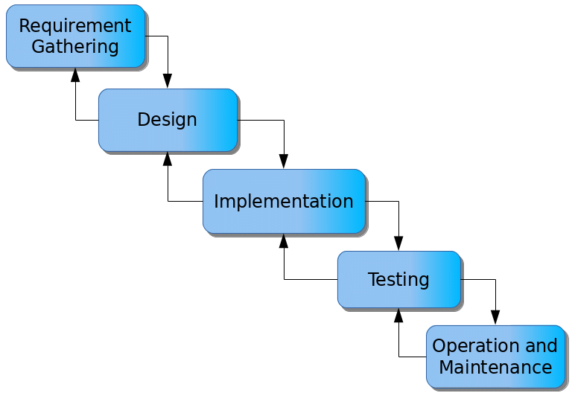

Figure 3.1: Waterfall model

**3.4.1.1 Requirements Gathering**

1. Project stakeholders, including students, staff, and event organizers, will be engaged to collect comprehensive information about event planning, scheduling, and management needs.
2. Specific requirements for user roles, event categories, and notification methods will be documented.
3. All gathered requirements will be meticulously recorded for reference throughout the system development process.

**3.4.1.2 System Design**

1. The system architecture will be developed, outlining the decision-making process and workflow for event management.
2. A database schema will be designed to store and retrieve event details, user profiles, and notifications efficiently.
3. A user-friendly interface will be created to allow organizers to add events, students to register for events, and administrators to oversee activities.

**3.4.1.3 Implementation**

1. The system design specifications will be translated into a functional web-based or mobile application, adhering to best practices in event management.
2. A notification system will be implemented to send real-time updates via email, SMS, or in-app alerts.
3. The database structure will be developed to ensure secure and efficient storage of event data and user information.

**3.4.1.4 Testing**

1. Unit testing will be conducted to validate the accuracy and functionality of individual system components.
2. Integration testing will be performed to verify the smooth interaction between various modules and databases.
3. System testing will be carried out to assess the overall performance, reliability, and user experience of the system.

**3.4.1.5 Maintenance**

1. Identified issues or system bugs will be promptly addressed based on user feedback and performance reviews.
2. Regular updates will be implemented to incorporate new features and improve system efficiency.
3. Future enhancements will be planned to ensure the system remains relevant to evolving campus event management needs.

By following this structured approach, the Campus Event Management System will streamline event planning, enhance user engagement, and improve overall event management on campus.

## 3.5 Methods of Data Collection

There are two main sources of data collection in carrying out this study, information was basically obtained from the two sources which are primary and secondary sources.

**Primary Source:** Primary source of data that will be used in this study will be personal interview and observation.

**Secondary Source:** The secondary data used in the study will be obtained from magazines, Journal, newspapers, library source and most of the information from the library research has been covered in my literature review in the previous chapter of this project.

## 3.6 System Design

## 3.6.1 UML Algorithm

**3.6.1.1 Use case diagram**

A use case diagram at its simplest is a representation of a user’s interaction with the system and depicting the specifications of a use case. A use case diagram shows the system and the various ways that they interact with the sub system.

**CAMPUS EVENT RECORD SYSTEM**

Register for an Event

Add Venue

View Events

Admin

View Reports

Login

Create/Add Event

Logout

Add Users

User/Student

Figure 3.2: Use Case Diagram

**3.6.1.2 Activity Diagram**

An activity diagram shows a flow of control in a system similar to a flowchart or a data flow diagram.

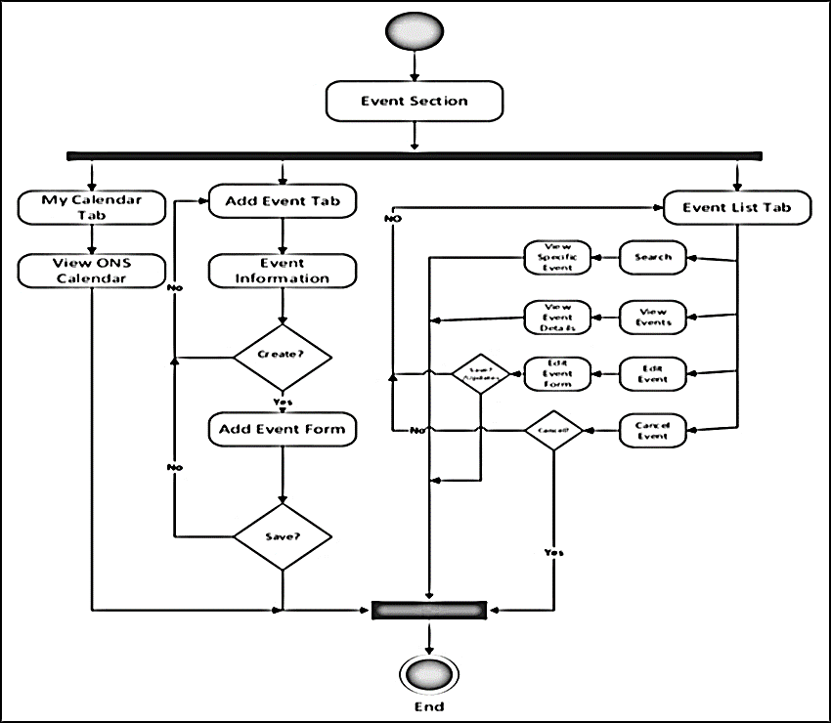

Figure 3.3: Activity diagram of the system

**3.6.2 System Architecture**



Database MySQL

Apache Server

**CAMPUS EVENT record SYSTEM**

Figure 3.4: System Architecture

## 3.6.3 Database Tables/Queries Structures

**Table 3.1: Admin Table**

| **Name** | **Type** | **Default** | **Extra** |
| --- | --- | --- | --- |
| **id Primary** | int(11) | *None* | AUTO_INCREMENT |
| **name** | varchar(50) | *None* |  |
| **username** | varchar(50) | *None* |  |
| **password** | varchar(50) | *None* |  |
| **type** | text | *None* |  |

**Table 3.2: Audience Table**

Top of Form

| **Name** | **Type** | **Null** | **Extra** |
| --- | --- | --- | --- |
| id Primary | int(11) | No | AUTO_INCREMENT |
| contact | varchar(15) | No |  |
| email Index | varchar(255) | No |  |
| address Index | varchar(255) | No |  |
| event_id | int(11) | No |  |
| payment_status | int(11) |  |  |
| attendance_status | int(11) |  |  |
| status | int(11) |  |  |
| date | datetime | No |  |

Bottom of Form

**Table 3.3: Venue Table**

Top of Form

Top of Form

Top of Form

| **Name** | **Type** | **Null** | **Extra** |
| --- | --- | --- | --- |
| **id Primary** | int(11) | No | AUTO_INCREMENT |
| **name Index** | varchar(255) | No |  |
| **Address** | longtext | No |  |
| **Description** | longtext | No |  |

Bottom of Form

**Table 3.4: Events Table**

| **Name** | **Type** | **Null** | **Extra** |
| --- | --- | --- | --- |
| **id Primary** | int(11) | No | AUTO_INCREMENT |
| **event_name** | varchar(120) | Yes |  |
| **venue_id** | bigint(12) | Yes |  |
| **description** | varchar(150) | Yes |  |
| **schedule** | datetime | Yes |  |
| **type** | int(10) | Yes |  |
| **audience_capacity** | int(15) | Yes |  |
| **payment_type** | int(20) | Yes |  |
| **amount** | Int(11) |  |  |
| **banner** | varchar(150) |  |  |
| **date_created** | timestamp | No |  |

## 3.6.4 Entity Relationship Model

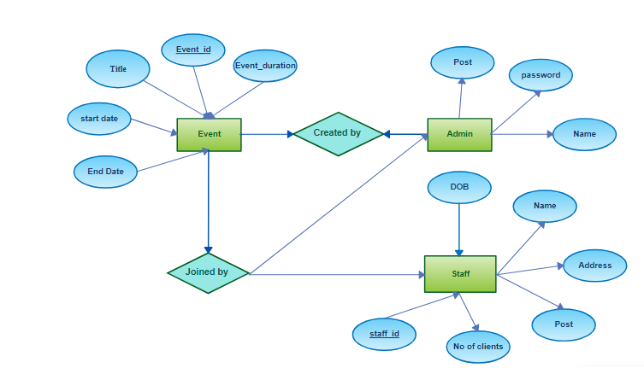

Figure 3.5: Entity Relationship Model

## 3.6.5 Database Entity Relationship Diagram

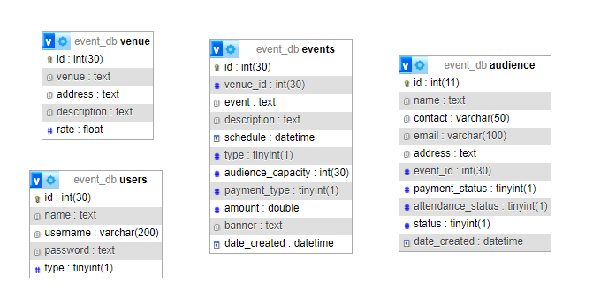

Figure 3.6: Database Entity Relationship Diagram

## 3.6.4 The Input and Output Design

**ADD EVENT FORM**

Event name

Venue

**Save Student**

Schedule

Description

Audience capacity

Image/Banner

Registration Fee

**Cancel**

Free for All

Figure 3.7: Add Event

**ADD EVENT FORM**

PHP coding competition

Lecture theatre II

**Save Student**

13/03/2025 10:00AM

PHP coding competition for all and is free with a cash price of 100,000.

50

**Cancel**

Free for All

Figure 3.8: Output Event Form

**REGISTER FOR AN EVENT**

Name

Address

**Save Student**

Contact

Email

**Cancel**

Figure 3.9: Register for an Event

**REGISTER FOR AN EVENT**

Lawrence Tochukwu

Federal Polytechnic, Mubi

**Save Student**

09122304241

tochukwulaw@gmail.com

**Cancel**

Figure 3.10: Output Register for an Event

**3.6.7 Report Layout**

**Table 3.5: Audience Report List**

**Audience List and Details**

**Event: PHP coding competition**

**Venue: Lecture Theatre (LT) 1**

| **Name** | **Email** | **Contact** | **Payment Status** |
| --- | --- | --- | --- |
| George Wilson | gwilson@sample.com | 08145654555 | Paid |
| Aisha Haruna | [aisha29@gmail.com](mailto:aisha29@gmail.com) | 09077882212 | Paid |
| Adi Richard | [richard@yahoo.com](mailto:richard@yahoo.com) | 08032458842 | Paid |

## 3.7 System Requirement Specification

## 3.7.1 Hardware Requirements

The software to be designed will need the following hardware for an effective operation.

1. A system running on intel, P(R) duo core with higher processor
2. The-Random Access Memory (RAM) should be at least 512MB.
3. At least 20-GB hard disk.
4. A colored monitor.
5. A mobile device.

## 3.7.2 Software Requirements

The software requirements include:

1. A window 7 or higher version of operating system.
2. XAMP or WAMP for Database
3. PHP
4. MySQL
5. Web browser

**3.7.3 Personnel Requirements**

The system will be design in such a way that it is user friendly in other to be understood and used by anyone with basic computer knowledge.

# CHAPTER FOUR

# RESULTS AND DISCUSSION

## 4.1 Introduction

This chapter presents the results and discussions of the newly developed system, which utilizes PHP and MySQL for efficient record insertion and updating. The system is designed to streamline the management and retrieval of information, thereby enhancing operational efficiency. In this chapter, we will explore the functionality and performance of the system, discussing its impact on data management and its effectiveness in meeting the intended objectives.

## 4.2 Results

**4.2.1 Welcome Interface**

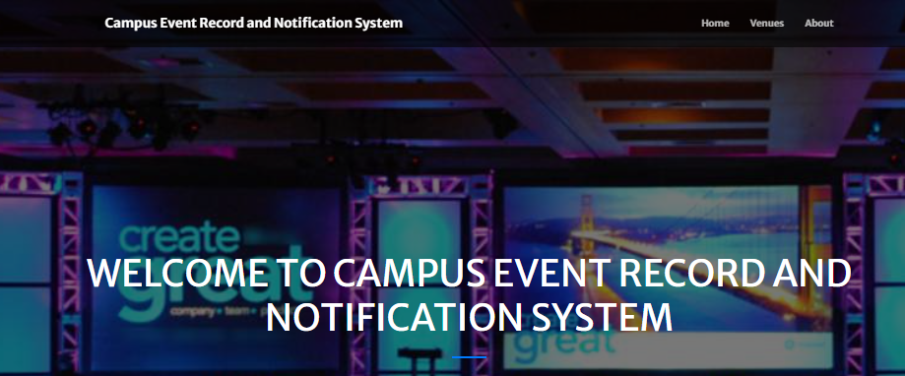

Figure 4.1: Welcome Interface

Figure 4.1 shows the welcome page of the Event Records System; the welcome page is the first page that displays the project topic.

**4.2.2 Login interface**

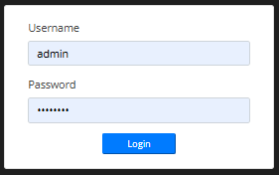

Figure 4.2: Login interface

Figure 4.2 above represents the user interface and workflow for gaining access into the system by entering the username and password.

**4.2.3 Add New Booking**

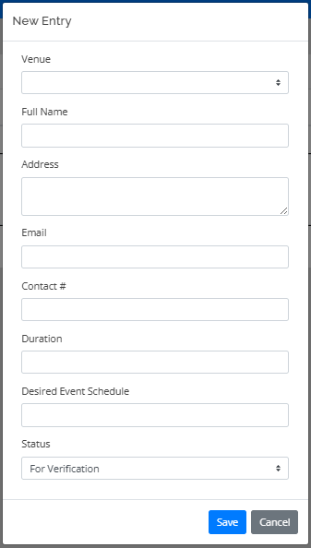

Figure 4.3: Add New Booking

Figure 4.3 above shows where new event booking can be made on the system by entering the booking details such as venue, name, address, contact details.

**4.2.4 Event List Interface**

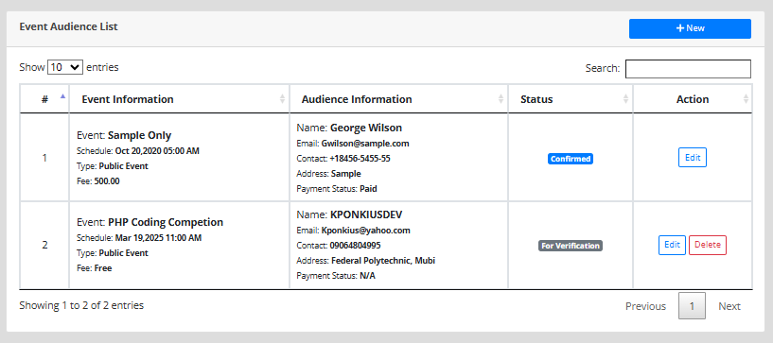

Figure 4.4: Event List Interface

Figure 4.4: This interface shows the records of all the events that have been registered on the system and related information about the event.

**4.2.5 Add Venue Interface**

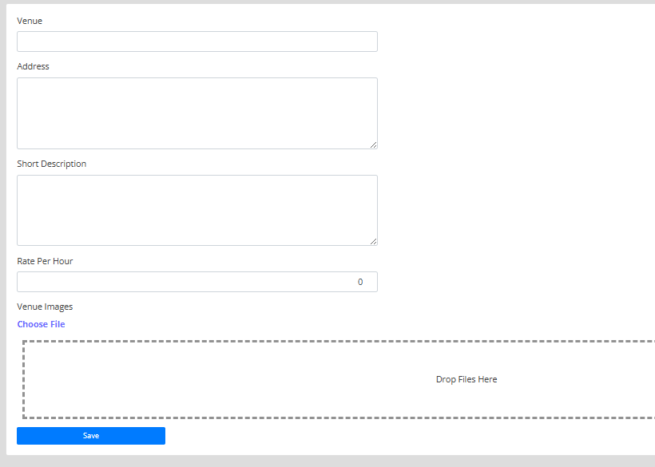

Figure 4.5: Add Venue Interface

Figure 4.5 shows the add venue interface where the admin can add a venue that will be used for booking.

**4.2.6 Venue list**

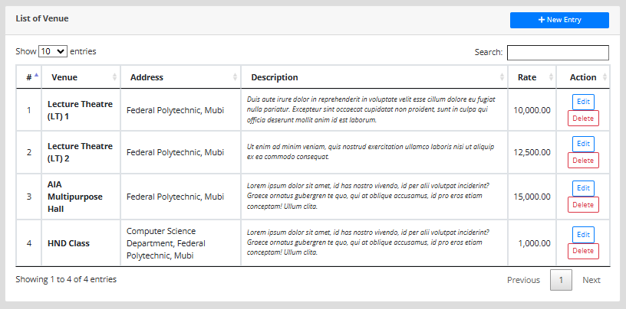

Figure 4.6: Venue list interface

Figure 4.6 shows all records of venue that are available for booking showing the venue name, address, description and amount to be paid for the venue.

## 4.3 Discussion

This section provides an in-depth discussion of the key interfaces that make up the event booking system. Each interface has been carefully designed to improve user experience and ensure functional efficiency in handling event bookings and venue management.

The Welcome Interface serves as the system’s homepage and is the user's first point of contact. It includes the system name, a logo, and navigation links to other parts of the system such as login or general information about events. This interface is crucial in creating a strong first impression and establishing an intuitive environment for users to begin interaction with the system. Figure 4.1 shows the layout of the Welcome Interface with navigation controls and branding elements clearly highlighted.

The Login Interface provides secure access to authorized users. It features input fields for username and password, as well as options for password recovery. This interface ensures user authentication and protects the system from unauthorized access. It is critical in maintaining system confidentiality, data integrity, and access control. Figure 4.2 illustrates the Login Interface, displaying the login form and security features implemented for user validation.

The Add New Booking Interface allows users to create new event reservations by filling out a form with necessary details like event name, date, venue, and expected number of guests. It includes form validation to avoid conflicts like double bookings and incorrect data entries. This interface directly supports the core function of the system event booking. Figure 4.3 presents the Add New Booking Interface with form fields and booking validation indicators.

The Event List Interface provides a dynamic view of all scheduled events in the system. It features options for sorting and filtering events by criteria such as date, venue, or type. Administrators and users can also perform actions such as viewing details, editing, or cancelling events from this interface. Figure 4.4 depicts the Event List Interface with a table of events and interactive controls for managing each entry.

The Add Venue Interface is used to register new event venues into the system. The form includes fields such as venue name, location, capacity, and available facilities. This interface supports the dynamic expansion of available venues and helps maintain an up-to-date list of suitable locations for events. Figure 4.5 displays the Add Venue Interface with input fields and confirmation messages for successful venue registration.

The Venue List Interface showcases all existing venues that have been registered in the system. It typically includes a searchable table format with columns for venue name, location, capacity, and availability status. This interface supports efficient venue selection and administration. Figure 4.6 shows the Venue List Interface with a structured list of venues, availability indicators, and management options.

## 4.4 User manual

## 4.4.1 System Installation

The user manual is a clear and precise instruction on how a user can operate the propose system, without any stress and successful. The following steps required

1. Start or boot the computer form the hard disk
2. Double click on the folder that program is been stored in the desktop
3. Double click on the program and allow it to load gently
4. A security unit will display were the user will specify the user name and password the click on OK.
5. A welcome menu will be displayed where the user has options to select which operation to be performed.
6. To find information about player, select any name and search.
7. Click on exist on the welcome screen to exist from the program.

## 4.4.2 System operational guide

The following are the necessary steps to take in order to use the system efficiently and effectively.

1. Load the url of the system <https://localhost/event/> the welcome page will be displayed.
2. Click on the **Proceed** button to proceed to the main system.
3. If you created an account, provide your login details by entering your username and password.
4. Depending on the login details provided you will be automatically directed to the dashboard.
5. The various task that you can perform on the portal will be displayed on the sidebar of the dashboard.

# CHAPTER FIVE

# SUMMARY, CONCLUSION AND RECOMMENDATIONS

## 5.1 Summary

This study was undertaken to design and implement a Campus Events Record and Notification System for Federal Polytechnic, Mubi. The system was aimed at addressing the challenges associated with poor student engagement, inadequate event information dissemination, and inefficient management of campus events. A comprehensive literature review revealed that many institutions still rely on manual or semi-digital approaches for event coordination, which often leads to low participation rates and communication gaps. The system developed features several core components, including an interactive registration interface that allows students to sign up for events and receive recommendations based on interests and event categories. It also includes a centralized event management platform for administrators to post and update event details and a real-time notification module that sends alerts about upcoming or rescheduled events.

Furthermore, various user-friendly interfaces were developed, including the Welcome Interface, Login Interface, Add New Booking, Event List, Add Venue, and Venue List Interfaces. Each interface was carefully designed to support usability, security, and functionality, ensuring both administrative and student users could effectively interact with the system. The system was evaluated in terms of user engagement, functionality, and responsiveness. Feedback from test users indicated improved awareness of campus events, enhanced participation, and better coordination between organizers and attendees.

## 5.2 Conclusion

The implementation of the Campus Events Record and Notification System has demonstrated significant potential in transforming how campus events are managed and communicated at Federal Polytechnic, Mubi. The study achieved all its objectives: the creation of an interactive interface for event registration, the development of a centralized platform for event management, and the implementation of a real-time notification feature.

This project highlights the importance of automation and digitalization in campus administration and student affairs. By moving away from manual record-keeping and fragmented communication channels, the institution can benefit from increased transparency, improved planning, and higher levels of student engagement. The real-time notification system, in particular, plays a crucial role in bridging the gap between event organizers and participants, ensuring timely and accurate dissemination of information. In essence, the system provides a scalable and sustainable solution that can be further customized or extended to include analytics, SMS/email integration, or mobile applications, making it even more robust and accessible.

## 5.3 Recommendations

Based on the outcomes of this study, the following recommendations are proposed:

1. The management of Federal Polytechnic, Mubi, should consider adopting the system officially and integrating it into the student portal for wider accessibility and regular use.
2. Regular updates should be made to the system to include new features such as mobile notifications, event feedback mechanisms, and RSVP tracking. Maintenance schedules should also be set to ensure system reliability.
3. Workshops and user training should be conducted for students and staff to ensure they understand how to use the system effectively and take full advantage of its features.
4. While the current system may have been designed for general campus events, it should be expanded to accommodate department-level events, clubs, and academic seminars, thereby increasing its relevance and usage.

# REFERENCES

Anderson, P., & White, K. (2023). *Digital Event Management for Higher Education Institutions.* Oxford University Press.

Davis, L. (2022). Challenges in Student Engagement and Campus Event Participation. *Journal of Educational Technology, 19*(4), 112-129.

El-Gazzar, R., Fahad, M., & Patil, V. (2020). *Event notification systems and technological advancements.* Springer.

Fahad, M., Khan, S., & Ali, T. (2023). *Event management in the digital age.* Wiley.

Garcia, L., & Adams, M. (2023). *Social Media Integration in Campus Events*. Journal of Event Technology, 15(2), 112-125.

Garcia, L., & Evans, P. (2022). *Addressing Digital Divide in Campus Event Management*. Journal of Educational Technology, 20(1), 78-91.

Harris, K. (2023). *Artificial Intelligence and Event Management*. Tech & Education Review, 12(3), 56-72.

Johnson, L., Roberts, A., & Clarke, P. (2023). Student Engagement in Digital Campus Event Management Systems. *Journal of Higher Education Research,* 36(2), 87-105.

Johnson, P., & Brown, T. (2022). *Higher education and student engagement through events.* Oxford University Press.

Johnson, T., & Carter, M. (2023). *Enhancing Campus Event Participation Through Digital Solutions*. Educational Technology Review, 14(3), 99-113.

Kim, S., & Lee, J. (2021). *Systems and technology in higher education.* Routledge.

Kumar, A. (2018). *Principles of management and organizational behavior.* McGraw-Hill.

Lee, S., Miller, D., & Evans, R. (2023). *Student Engagement Analytics in Campus Events*. Journal of Higher Education Management, 19(2), 150-164.

Miller, J., & Evans, S. (2022). Enhancing Student Participation through Digital Event Platforms. *Journal of Educational Research, 34*(1), 98-115.

Patel, S. (2022). *Budget Constraints in Implementing Event Management Systems*. Journal of Institutional Technology, 16(3), 210-225.

Patil, V., Mehta, R., & Singh, A. (2024). *The role of ICT in modern communication.* Elsevier.

Rogers, E. M. (2003). Diffusion of Innovations (5th ed.). Free Press.

Shannon, C. E., & Weaver, W. (1949). The Mathematical Theory of Communication. University of Illinois Press.

Smith, J. (2023). *Trends in campus communication and event management.* Harvard University Press.

Smith, J., & Lee, C. (2023). *Optimizing Resource Allocation in Campus Event Management*. International Conference on Event Planning Proceedings, 22(5), 67-81.

Smith, J., Williams, K., & Carter, M. (2022). *Challenges of Traditional Event Planning in Universities*. Higher Education Studies, 13(3), 205-219.

Thomas, R., & Scott, E. (2023). *Feedback Collection and Student Event Participation Trends*. Education & Event Research, 17(1), 144-158.

Williams, K., & Carter, M. (2023). *Encouraging Technology Adoption in Campus Event Planning*. Journal of Digital Education, 19(4), 75-89.

Williams, K., & Clarke, D. (2021). *Cloud-Based Solutions for Campus Events*. Journal of Technology and Society, 14(2), 102-118.

Williams, K., Evans, P., & Clarke, D. (2022). *Impact of Digital Event Management on Student Engagement*. Education & Digital Society, 15(1), 90-105.

Williams, T., Roberts, L., & Clarke, P. (2021). Web-Based Platforms for Campus Event Management. *Journal of Higher Education Technology, 15*(2), 67-89.

# APPENDIX A

Welcome Interface



Login interface



Event List Interface



Add New Booking



Add Venue Interface



Venue list



# APPENDIX B

**PROGRAM CODE**

**HOME PAGE**

<?php

include 'admin/db_connect.php';

?>

        <header class="masthead">

            <div class="container-fluid h-100">

                <div class="row h-100 align-items-center justify-content-center text-center">

                    <div class="col-lg-8 align-self-end mb-4 page-title">

                        <h1 class="text-white text-uppercase">Welcome to <?php echo $_SESSION['system']['name']; ?></h1>

                        <hr class="divider my-4" />

                    <div class="col-md-12 mb-2 justify-content-center">

                    </div>

                    </div>

                </div>

            </div>

        </header>

            <div class="container mt-3 pt-2">

                <h4 class="text-center text-white">Upcoming Events</h4>

                <hr class="divider">

                <?php

                $event = $conn->query("SELECT e.*,v.venue FROM events e inner join venue v on v.id=e.venue_id where date_format(e.schedule,'%Y-%m%-d') >= '".date('Y-m-d')."' and e.type = 1 order by unix_timestamp(e.schedule) asc");

                while($row = $event->fetch_assoc()):

                    $trans = get_html_translation_table(HTML_ENTITIES,ENT_QUOTES);

                    unset($trans["\""], $trans["<"], $trans[">"], $trans["<h2"]);

                    $desc = strtr(html_entity_decode($row['description']),$trans);

                    $desc=str_replace(array("<li>","</li>"), array("",","), $desc);

                ?>

                <div class="card event-list" data-id="<?php echo $row['id'] ?>">

                     <div class='banner'>

                        <?php if(!empty($row['banner'])): ?>

                            <img src="admin/assets/uploads/<?php echo($row['banner']) ?>" alt="">

                        <?php endif; ?>

                    </div>

                    <div class="card-body">

                        <div class="row  align-items-center justify-content-center text-center h-100">

                            <div class="">

                                <h3><b class="filter-txt"><?php echo ucwords($row['event']) ?></b></h3>

                                <div><small><p><b><i class="fa fa-calendar"></i> <?php echo date("F d, Y h:i A",strtotime($row['schedule'])) ?></b></p></small></div>

                                <hr>

                                <larger class="truncate filter-txt"><?php echo strip_tags($desc) ?></larger>

                                <br>

                                <hr class="divider"  style="max-width: calc(80%)">

                                <button class="btn btn-primary float-right read_more" data-id="<?php echo $row['id'] ?>">Read More</button>

                            </div>

                        </div>

                    </div>

                </div>

                <br>

                <?php endwhile; ?>

            </div>

<script>

     $('.read_more').click(function(){

         location.href = "index.php?page=view_event&id="+$(this).attr('data-id')

     })

     $('.banner img').click(function(){

        viewer_modal($(this).attr('src'))

    })

    $('#filter').keyup(function(e){

        var filter = $(this).val()

        $('.card.event-list .filter-txt').each(function(){

            var txto = $(this).html();

            txt = txto

            if((txt.toLowerCase()).includes((filter.toLowerCase())) == true){

                $(this).closest('.card').toggle(true)

            }else{

                $(this).closest('.card').toggle(false)

            }

        })

    })

    <body id="page-top">

        <!-- Navigation-->

        <div class="toast" id="alert_toast" role="alert" aria-live="assertive" aria-atomic="true">

        <div class="toast-body text-white">

        </div>

      </div>

        <nav class="navbar navbar-expand-lg navbar-light fixed-top py-3" id="mainNav">

            <div class="container">

                <a class="navbar-brand js-scroll-trigger" href="./"><?php echo $_SESSION['system']['name'] ?></a>

                <button class="navbar-toggler navbar-toggler-right" type="button" data-toggle="collapse" data-target="#navbarResponsive" aria-controls="navbarResponsive" aria-expanded="false" aria-label="Toggle navigation"><span class="navbar-toggler-icon"></span></button>

                <div class="collapse navbar-collapse" id="navbarResponsive">

                    <ul class="navbar-nav ml-auto my-2 my-lg-0">

                        <li class="nav-item"><a class="nav-link js-scroll-trigger" href="index.php?page=home">Home</a></li>

                        <li class="nav-item"><a class="nav-link js-scroll-trigger" href="index.php?page=venue">Venues</a></li>

                        <li class="nav-item"><a class="nav-link js-scroll-trigger" href="index.php?page=about">About</a></li>

                                            </ul>

                </div>

            </div>

        </nav>

**BOOKING PAGE**

        <?php

        $page = isset($_GET['page']) ?$_GET['page'] : "home";

        include $page.'.php';

        ?>

<div class="modal fade" id="confirm_modal" role='dialog'>

    <div class="modal-dialog modal-md" role="document">

      <div class="modal-content">

        <div class="modal-header">

        <h5 class="modal-title">Confirmation</h5>

      </div>

      <div class="modal-body">

        <div id="delete_content"></div>

      </div>

      <div class="modal-footer">

        <button type="button" class="btn btn-primary" id='confirm' onclick="">Continue</button>

        <button type="button" class="btn btn-secondary" data-dismiss="modal">Close</button>

      </div>

      </div>

    </div>

  </div>

  <div class="modal fade" id="uni_modal" role='dialog'>

    <div class="modal-dialog modal-md" role="document">

      <div class="modal-content">

        <div class="modal-header">

        <h5 class="modal-title"></h5>

      </div>

      <div class="modal-body">

      </div>

      <div class="modal-footer">

        <button type="button" class="btn btn-primary" id='submit' onclick="$('#uni_modal form').submit()">Save</button>

        <button type="button" class="btn btn-secondary" data-dismiss="modal">Cancel</button>

      </div>

      </div>

    </div>

  </div>

  <div class="modal fade" id="uni_modal_right" role='dialog'>

    <div class="modal-dialog modal-full-height  modal-md" role="document">

      <div class="modal-content">

        <div class="modal-header">

        <h5 class="modal-title"></h5>

        <button type="button" class="close" data-dismiss="modal" aria-label="Close">

          <span class="fa fa-arrow-righ t"></span>

        </button>

      </div>

      <div class="modal-body">

      </div>

      </div>

    </div>

  </div>

  <div class="modal fade" id="viewer_modal" role='dialog'>

    <div class="modal-dialog modal-md" role="document">

      <div class="modal-content">

              <button type="button" class="btn-close" data-dismiss="modal"><span class="fa fa-times"></span></button>

              <img src="" alt="">

      </div>

    </div>

  </div>

  <div id="preloader"></div>

        <footer class=" py-5">

            <div class="container">

                <div class="row justify-content-center">

                    <div class="col-lg-8 text-center">

                        <h2 class="mt-0 text-white">Contact us</h2>

                        <hr class="divider my-4" />

                    </div>

                </div>

                <div class="row">

                    <div class="col-lg-4 ml-auto text-center mb-5 mb-lg-0">

                        <i class="fas fa-phone fa-3x mb-3 text-muted"></i>

                        <div class="text-white"><?php echo $_SESSION['system']['contact'] ?></div>

                    </div>

                    <div class="col-lg-4 mr-auto text-center">

                        <i class="fas fa-envelope fa-3x mb-3 text-muted"></i>

                        <!-- Make sure to change the email address in BOTH the anchor text and the link target below!-->

                        <a class="d-block" href="mailto:<?php echo $_SESSION['system']['email'] ?>"><?php echo $_SESSION['system']['email'] ?></a>

                    </div>

                </div>

            </div>

            <br>

            <div class="container"><div class="small text-center text-muted">Copyright © 2020 - <?php echo $_SESSION['system']['name'] ?> | <a href="" target="_blank">KponkiusDev Team</a></div></div>

        </footer>

       <?php include('footer.php') ?>

    </body>

    <?php $conn->close() ?>

</html>

**VENUE CODE**

        <meta charset="utf-8" />

        <meta name="viewport" content="width=device-width, initial-scale=1, shrink-to-fit=no" />

        <meta name="description" content="" />

        <meta name="author" content="" />

        <title><?php echo $_SESSION['system']['name'] ?></title>

        <!-- Favicon-->

        <link rel="icon" type="image/x-icon" href="assets/img/favicon.ico" />

        <!-- Font Awesome icons (free version)-->

        <script src="https://use.fontawesome.com/releases/v5.13.0/js/all.js" crossorigin="anonymous"></script>

        <!-- Google fonts-->

        <link href="https://fonts.googleapis.com/css?family=Merriweather+Sans:400,700" rel="stylesheet" />

        <link href="https://fonts.googleapis.com/css?family=Merriweather:400,300,300italic,400italic,700,700italic" rel="stylesheet" type="text/css" />

        <!-- Third party plugin CSS-->

        <link href="admin/assets/css/jquery.datetimepicker.min.css" rel="stylesheet">

        <link href="https://cdnjs.cloudflare.com/ajax/libs/magnific-popup.js/1.1.0/magnific-popup.min.css" rel="stylesheet" />

        <!-- Core theme CSS (includes Bootstrap)-->

        <link href="admin/assets/vendor/bootstrap-datepicker/css/bootstrap-datepicker.css" rel="stylesheet" />

        <link href="css/styles.css" rel="stylesheet" />

         <link href="admin/assets/css/select2.min.css" rel="stylesheet">

        <script src="admin/assets/vendor/jquery/jquery.min.js"></script>

        <script src="admin/assets/vendor/bootstrap-datepicker/js/bootstrap-datepicker.js"></script>

    <script type="text/javascript" src="admin/assets/js/select2.min.js"></script>

    <script type="text/javascript" src="admin/assets/js/jquery.datetimepicker.full.min.js"></script>

<?php

include 'admin/db_connect.php';

?>

<style>

#portfolio .img-fluid{

    width: calc(100%);

    height: 30vh;

    z-index: -1;

    position: relative;

    padding: 1em;

}

.venue-list{

cursor: pointer;

border: unset;

flex-direction: inherit;

}

.venue-list .carousel,.venue-list .card-body {

    width: calc(50%)

}

.venue-list .carousel img.d-block.w-100 {

    border-top-left-radius: 5px;

    border-bottom-left-radius: 5px;

    min-height: 50vh;

}

span.hightlight{

    background: yellow;

}

.carousel,.carousel-inner,.carousel-item{

   min-height: calc(100%)

}

header.masthead,header.masthead:before {

        min-height: 50vh !important;

        height: 50vh !important

    }

.row-items{

    position: relative;

}

.card-left{

    left:0;

}

.card-right{

    right:0;

}

.rtl{

    direction: rtl ;

}

.venue-text{

    justify-content: center;

    align-items: center ;

}

</style>

        <header class="masthead">

        </header>

            <div class="container-fluid mt-3 pt-2">

                <h4 class="text-center text-white">List of Our Event Venues</h4>

                <hr class="divider">

                <div class="row-items">

                <div class="col-lg-12">

                    <div class="row">

                <?php

                $rtl ='rtl';

                $ci= 0;

                $venue = $conn->query("SELECT * from venue order by rand()");

                while($row = $venue->fetch_assoc()):

                    $ci++;

                    if($ci < 3){

                        $rtl = '';

                    }else{

                        $rtl = 'rtl';

                    }

                    if($ci == 4){

                        $ci = 0;

                    }

                ?>

                <div class="col-md-6">

                <div class="card venue-list <?php echo $rtl ?>" data-id="<?php echo $row['id'] ?>">

                        <div id="imagesCarousel_<?php echo $row['id'] ?> card-img-top " class="carousel slide" data-ride="carousel">

                            <?php ?>

                              <div class="carousel-inner">

                                    <?php

                                        $images = array();

                                        $fpath = 'admin/assets/uploads/venue_'.$row['id'];

                                        $images= scandir($fpath);

                                        $i = 1;

                                        foreach($images as $k => $v):

                                            if(!in_array($v,array('.','..'))):

                                                $active = $i == 1 ? 'active' : '';

                                    ?>

                                         <div class="carousel-item <?php echo $active ?>">

                                          <img class="d-block w-100" src="<?php echo $fpath.'/'.$v ?>" alt="">

                                        </div>

                                    <?php

                                            $i++;

                                            else:

                                                unset($images[$v]);

                                            endif;

                                        endforeach;

                                    ?>

                                     <a class="carousel-control-prev" href="#imagesCarousel_<?php echo $row['id'] ?>" role="button" data-slide="prev">

                                        <span class="carousel-control-prev-icon" aria-hidden="true"></span>

                                        <span class="sr-only">Previous</span>

                                      </a>

                                      <a class="carousel-control-next" href="#imagesCarousel_<?php echo $row['id'] ?>" role="button" data-slide="next">

                                        <span class="carousel-control-next-icon" aria-hidden="true"></span>

                                        <span class="sr-only">Next</span>

                                      </a>

                                        </div>

                                    </div>

                    <div class="card-body">

                        <div class="row align-items-center justify-content-center text-center h-100">

                            <div class="">

                                <div>

                                    <h3><b class="filter-txt"><?php echo ucwords($row['venue']) ?></b></h3>

                                    <small><i><?php echo $row['address'] ?></i></small>

                                </div>

                                <div>

                                <span class="truncate" style="font-size: inherit;"><small><?php echo ucwords($row['description']) ?></small></span>

                                    <br>

                                <span class="badge badge-secondary"><i class="fa fa-tag"></i> Rate Per Hour: <?php echo number_format($row['rate'],2) ?></span>

                                <br>

                                <br>

                                <button class="btn btn-primary book-venue align-self-end" type="button" data-id='<?php echo $row['id'] ?>'>Book</button>

                                </div>

                            </div>

                        </div>

                    </div>

                </div>

                <br>

                </div>

                <?php endwhile; ?>

                </div>

                </div>

                </div>

            </div>

**REGISTRATION**

<script>

    // $('.card.venue-list').click(function(){

    //     location.href = "index.php?page=view_venue&id="+$(this).attr('data-id')

    // })

    $('.book-venue').click(function(){

        uni_modal("Submit Booking Request","booking.php?venue_id="+$(this).attr('data-id'))

    })

    $('.venue-list .carousel img').click(function(){

        viewer_modal($(this).attr('src'))

    })

</script>

<div class="container-fluid">

    <form action="" id="manage-register">

        <input type="hidden" name="id" value="<?php echo isset($id) ? $id :'' ?>">

        <input type="hidden" name="event_id" value="<?php echo isset($_GET['event_id']) ? $_GET['event_id'] :'' ?>">

        <div class="form-group">

            <label for="" class="control-label">Full Name</label>

            <input type="text" class="form-control" name="name"  value="<?php echo isset($name) ? $name :'' ?>" required>

        </div>

        <div class="form-group">

            <label for="" class="control-label">Address</label>

            <textarea cols="30" rows = "2" required="" name="address" class="form-control"><?php echo isset($address) ? $address :'' ?></textarea>

        </div>

        <div class="form-group">

            <label for="" class="control-label">Email</label>

            <input type="email" class="form-control" name="email"  value="<?php echo isset($email) ? $email :'' ?>" required>

        </div>

        <div class="form-group">

            <label for="" class="control-label">Contact #</label>

            <input type="text" class="form-control" name="contact"  value="<?php echo isset($contact) ? $contact :'' ?>" required>

        </div>

    </form>

</div>

<script>

     $('.datetimepicker').datetimepicker({

          format:'Y/m/d H:i',

          startDate: '+3d'

      })

    $('#manage-register').submit(function(e){

        e.preventDefault()

        start_load()

        $('#msg').html('')

        $.ajax({

            url:'admin/ajax.php?action=save_register',

            data: new FormData($(this)[0]),

            cache: false,

            contentType: false,

            processData: false,

            method: 'POST',

            type: 'POST',

            success:function(resp){

                if(resp==1){

                    alert_toast("Registration Request Sent.",'success')

                        end_load()

                        uni_modal("","register_msg.php")

                }

            }

        })

    })

</script>

<div class="container-fluid">

  <form action="" id="manage-book">

    <input type="hidden" name="id" value="<?php echo isset($id) ? $id :'' ?>">

    <input type="hidden" name="venue_id" value="<?php echo isset($_GET['venue_id']) ? $_GET['venue_id'] :'' ?>">

    <div class="form-group">

      <label for="" class="control-label">Full Name</label>

      <input type="text" class="form-control" id="alphaOnly" name="name" value="<?php echo isset($name) ? $name :'' ?>" required>

    </div>

    <div class="form-group">

      <label for="" class="control-label">Address</label>

      <textarea cols="30" rows="2" required name="address" class="form-control"><?php echo isset($address) ? $address :'' ?></textarea>

    </div>

    <div class="form-group">

      <label for="" class="control-label">Email</label>

      <input type="email" class="form-control" name="email" value="<?php echo isset($email) ? $email :'' ?>" required>

    </div>

    <div class="form-group">

      <label for="" class="control-label">Contact #</label>

      <input type="text" id="contactOnly" class="form-control" name="contact" value="<?php echo isset($contact) ? $contact :'' ?>" required>

    </div>

    <div class="form-group">

      <label for="" class="control-label">Duration</label>

      <input type="text" id="durationOnly" class="form-control" name="duration" value="<?php echo isset($duration) ? $duration :'' ?>" required>

    </div>

    <div class="form-group">

      <label for="" class="control-label">Desired Event Schedule</label>

      <input type="text" id="dateInput" class="form-control datetimepicker" name="schedule" value="<?php echo isset($schedule) ? $schedule :'' ?>" required>

    </div>

  </form>

</div>

<script>

  // Allow only alphabets in Full Name

  const alphaInput = document.getElementById('alphaOnly');

  alphaInput.addEventListener('keypress', function (e) {

    const char = String.fromCharCode(e.which);

    if (!/[a-zA-Z\s]/.test(char)) e.preventDefault(); // allow space too

  });

  alphaInput.addEventListener('paste', function (e) {

    e.preventDefault();

    const paste = (e.clipboardData || window.clipboardData).getData('text');

    this.value += paste.replace(/[^a-zA-Z\s]/g, '');

  });

  // Allow only numbers in Contact and Duration fields

  ['contactOnly', 'durationOnly'].forEach(id => {

    const input = document.getElementById(id);

    input.addEventListener('keypress', function (e) {

      const char = String.fromCharCode(e.which);

      if (!/[0-9]/.test(char)) e.preventDefault();

    });

    input.addEventListener('paste', function (e) {

      e.preventDefault();

      const paste = (e.clipboardData || window.clipboardData).getData('text');

      this.value += paste.replace(/[^0-9]/g, '');

    });

  });

  // Prevent past dates in date input

  $(document).ready(function () {

    $('.datetimepicker').datetimepicker({

      format: 'Y/m/d H:i',

      minDate: 0, // 🚫 Disallow past dates

      onShow: function(ct, input) {

        const selectedDate = new Date(input.val());

        const now = new Date();

        // If selected date is today, restrict time to future only

        if (

          selectedDate.toDateString() === now.toDateString()

        ) {

          this.setOptions({

            minTime: now.getHours() + ':' + (now.getMinutes() < 10 ? '0' : '') + now.getMinutes()

          });

        } else {

          this.setOptions({ minTime: false }); // Reset minTime for future dates

        }

      }

    });

  });

  $('#manage-book').submit(function(e){

    e.preventDefault();

    start_load();

    $('#msg').html('');

    $.ajax({

      url: 'admin/ajax.php?action=save_book',

      data: new FormData($(this)[0]),

      cache: false,

      contentType: false,

      processData: false,

      method: 'POST',

      type: 'POST',

      success: function(resp){

        if(resp == 1){

          alert_toast("Book Request Sent.", 'success');

          end_load();

          uni_modal("", "book_msg.php");

        }

      }

    });

  });

</script>

**VIEW EVENTS**

<?php include 'admin/db_connect.php' ?>

<?php

if(isset($_GET['id'])){

$qry = $conn->query("SELECT e.*,v.venue FROM events e inner join venue v on v.id=e.venue_id where e.id= ".$_GET['id']);

foreach($qry->fetch_array() as $k => $val){

    $$k=$val;

}

}

?>

<style type="text/css">

    .imgs{

        margin: .5em;

        max-width: calc(100%);

        max-height: calc(100%);

    }

    .imgs img{

        max-width: calc(100%);

        max-height: calc(100%);

        cursor: pointer;

    }

    #imagesCarousel,#imagesCarousel .carousel-inner,#imagesCarousel .carousel-item{

        height: 40vh !important;background: black;

    }

    #imagesCarousel{

        margin-left:unset !important ;

    }

    #imagesCarousel .carousel-item.active{

        display: flex !important;

    }

    #imagesCarousel .carousel-item-next{

        display: flex !important;

    }

    #imagesCarousel .carousel-item img{

        margin: auto;

        margin-top: unset;

        margin-bottom: unset;

    }

    #imagesCarousel img{

        width: calc(100%)!important;

        height: auto!important;

        /*max-height: calc(100%)!important;*/

        max-width: calc(100%)!important;

        cursor :pointer;

    }

    #banner{

        display: flex;

        justify-content: center;

    }

    #banner img{

        max-width: calc(100%);

        max-height: 50vh;

        cursor :pointer;

    }

    <?php if(!empty($banner)): ?>

     header.masthead {

        background: url(admin/assets/uploads/<?php echo $banner ?>);

        background-repeat: no-repeat;

        background-size: cover;

    }

    <?php endif; ?>

</style>

<header class="masthead">

    <div class="container-fluid h-100">

                <div class="row h-100 align-items-center justify-content-center text-center">

                    <div class="col-lg-4 align-self-end mb-4 pt-2 page-title">

                        <h4 class="text-center text-white"><b><?php echo ucwords($event) ?></b></h4>

                        <hr class="divider my-4" />

                        <p class="text-center text-white"><small><b><i>Venue: <?php echo ucwords($venue) ?></small></i></b></p>

                    </div>

                </div>

            </div>

</header>

<section></section>

<div class="container">

    <div class="col-lg-12">

        <div class="card mt-4 mb-4">

            <div class="card-body">

                <div class="row">

                    <div class="col-md-12">

                    </div>

                    <div class="col-md-12" id="content">

                        <div id="imagesCarousel" class="carousel slide col-sm-4 float-left  ml-0 mx-4"  data-ride="carousel">

                              <div class="carousel-inner">

                        <?php

                            $images = array();

                            if(isset($id)){

                                $fpath = 'admin/assets/uploads/event_'.$id;

                                $images= scandir($fpath);

                            }

                            $i = 1;

                            foreach($images as $k => $v):

                                if(!in_array($v,array('.','..'))):

                                    $active = $i == 1 ? 'active' : '';

                        ?>

                             <div class="carousel-item <?php echo $active ?>">

                              <img class="img-fluid" src="<?php echo $fpath.'/'.$v ?>" alt="">

                            </div>

                        <?php

                                $i++;

                                else:

                                    unset($images[$v]);

                                endif;

                            endforeach;

                        ?>

                         <a class="carousel-control-prev" href="#imagesCarousel" role="button" data-slide="prev">

                            <span class="carousel-control-prev-icon" aria-hidden="true"></span>

                            <span class="sr-only">Previous</span>

                          </a>

                          <a class="carousel-control-next" href="#imagesCarousel" role="button" data-slide="next">

                            <span class="carousel-control-next-icon" aria-hidden="true"></span>

                            <span class="sr-only">Next</span>

                          </a>

                            </div>

                            <ol class="carousel-indicators">

                                <?php for($v = 0 ;$v< ($i-1);$v++): ?>

                                <li data-target="#imagesCarousel" data-slide-to="<?php echo $v ?>" class="<?php echo ($v == 0) ?'active' : '' ?>"></li>

                                <?php endfor; ?>

                          </ol>

                        </div>

                    <p class="">

                        <p><b><i class="fa fa-calendar"></i> <?php echo date("F d, Y h:i A",strtotime($schedule)) ?></b></p>

                        <?php echo html_entity_decode($description); ?>

                    </p>

                    </div>

                </div>

                <div class="row">

                    <div class="col-md-12">

                        <hr class="divider" style="max-width: calc(100%);"/>

                        <div class="text-center">

                            <button class="btn btn-primary" id="register" type="button">Register</button>

                        </div>

                    </div>

                </div>

            </div>

        </div>

    </div>

</div>

<script>

    $('#imagesCarousel img,#banner img').click(function(){

        viewer_modal($(this).attr('src'))

    })

     $('#register').click(function(){

        uni_modal("Submit Registration Request","registration.php?event_id=<?php echo $id ?>")

    })

</script>

**ADMIN**

<?php include 'db_connect.php' ?>

<?php

if(isset($_GET['id'])){

$booking = $conn->query("SELECT * from venue_booking where id = ".$_GET['id']);

foreach($booking->fetch_array() as $k => $v){

    $$k = $v;

}

}

?>

<div class="container-fluid">

    <form action="" id="manage-book">

        <input type="hidden" name="id" value="<?php echo isset($id) ? $id :'' ?>">

        <div class="form-group">

            <label for="" class="control-label">Venue</label>

            <select name="venue_id" id="" class="custom-select select2">

                <option></option>

                <?php

                $venue = $conn->query("SELECT * FROM venue order by venue asc");

                while($row=$venue->fetch_assoc()):

                ?>

                <option value="<?php echo $row['id'] ?>" <?php echo isset($venue_id) && $venue_id == $row['id'] ? 'selected' : '' ?>><?php echo ucwords($row['venue']) ?></option>

            <?php endwhile; ?>

            </select>

        </div>

        <div class="form-group">

            <label for="" class="control-label">Full Name</label>

            <input type="text" class="form-control" name="name"  value="<?php echo isset($name) ? $name :'' ?>" required>

        </div>

        <div class="form-group">

            <label for="" class="control-label">Address</label>

            <textarea cols="30" rows = "2" required="" name="address" class="form-control"><?php echo isset($address) ? $address :'' ?></textarea>

        </div>

        <div class="form-group">

            <label for="" class="control-label">Email</label>

            <input type="email" class="form-control" name="email"  value="<?php echo isset($email) ? $email :'' ?>" required>

        </div>

        <div class="form-group">

            <label for="" class="control-label">Contact #</label>

            <input type="text" class="form-control" name="contact"  value="<?php echo isset($contact) ? $contact :'' ?>" required>

        </div>

        <div class="form-group">

            <label for="" class="control-label">Duration</label>

            <input type="text" class="form-control" name="duration"  value="<?php echo isset($duration) ? $duration :'' ?>" required>

        </div>

        <div class="form-group">

            <label for="" class="control-label">Desired Event Schedule</label>

            <input type="text" class="form-control datetimepicker" name="schedule"  value="<?php echo isset($datetime) ? date("Y-m-d H:i",strtotime($datetime)) :'' ?>" required>

        </div>

        <div class="form-group">

            <label for="" class="control-label">Status</label>

            <select name="status" id="" class="custom-select">

                <option value="0" <?php echo isset($status) && $status == 0 ? "selected" : '' ?>>For Verification</option>

                <option value="1" <?php echo isset($status) && $status == 1 ? "selected" : '' ?>>Confirmed</option>

                <option value="2" <?php echo isset($status) && $status == 2 ? "selected" : '' ?>>Cancelled</option>

            </select>

        </div>

    </form>

</div>

<script>

    $('#manage-book').submit(function(e){

        e.preventDefault()

        start_load()

        $.ajax({

            url:'ajax.php?action=save_book',

            method:"POST",

            data:$(this).serialize(),

            success:function(resp){

                if(resp == 1){

                    alert_toast("Book successfully updated","success")

                    setTimeout(function(){

                        location.reload()

                    },1500)

                }

            }

        })

    })

</script>

**USERS**

<?php

?>

<div class="container-fluid">

    <div class="row">

    <div class="col-lg-12">

            <button class="btn btn-primary float-right btn-sm" id="new_user"><i class="fa fa-plus"></i> New user</button>

    </div>

    </div>

    <br>

    <div class="row">

        <div class="card col-lg-12">

            <div class="card-body">

                <table class="table-striped table-bordered col-md-12">

            <thead>

                <tr>

                    <th class="text-center">#</th>

                    <th class="text-center">Name</th>

                    <th class="text-center">Username</th>

                    <th class="text-center">Type</th>

                    <th class="text-center">Action</th>

                </tr>

            </thead>

            <tbody>

                <?php

                    include 'db_connect.php';

                    $type = array("","Admin","Staff");

                    $users = $conn->query("SELECT * FROM users order by name asc");

                    $i = 1;

                    while($row= $users->fetch_assoc()):

                 ?>

                 <tr>

                    <td class="text-center">

                        <?php echo $i++ ?>

                    </td>

                    <td>

                        <?php echo ucwords($row['name']) ?>

                    </td>

                    <td>

                        <?php echo $row['username'] ?>

                    </td>

                    <td>

                        <?php echo $type[$row['type']] ?>

                    </td>

                    <td>

                        <center>

                                <div class="btn-group">

                                  <button type="button" class="btn btn-primary">Action</button>

                                  <button type="button" class="btn btn-primary dropdown-toggle dropdown-toggle-split" data-toggle="dropdown" aria-haspopup="true" aria-expanded="false">

                                    <span class="sr-only">Toggle Dropdown</span>

                                  </button>

                                  <div class="dropdown-menu">

                                    <a class="dropdown-item edit_user" href="javascript:void(0)" data-id = '<?php echo $row['id'] ?>'>Edit</a>

                                    <div class="dropdown-divider"></div>

                                    <a class="dropdown-item delete_user" href="javascript:void(0)" data-id = '<?php echo $row['id'] ?>'>Delete</a>

                                  </div>

                                </div>

                                </center>

                    </td>

                 </tr>

                <?php endwhile; ?>

            </tbody>

        </table>

            </div>

        </div>

    </div>

</div>

<script>

    $('table').dataTable();

$('#new_user').click(function(){

    uni_modal('New User','manage_user.php')

})

$('.edit_user').click(function(){

    uni_modal('Edit User','manage_user.php?id='+$(this).attr('data-id'))

})

$('.delete_user').click(function(){

        _conf("Are you sure to delete this user?","delete_user",[$(this).attr('data-id')])

    })

    function delete_user($id){

        start_load()

        $.ajax({

            url:'ajax.php?action=delete_user',

            method:'POST',

            data:{id:$id},

            success:function(resp){

                if(resp==1){

                    alert_toast("Data successfully deleted",'success')

                    setTimeout(function(){

                        location.reload()

                    },1500)

                }

            }

        })

    }

</script>